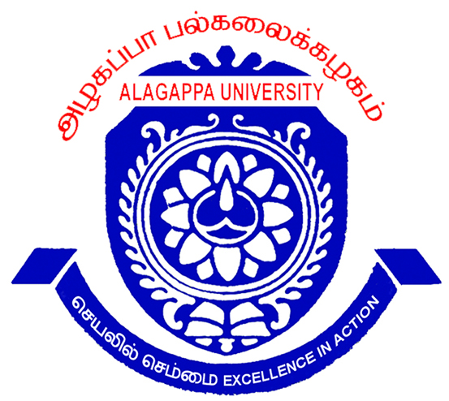
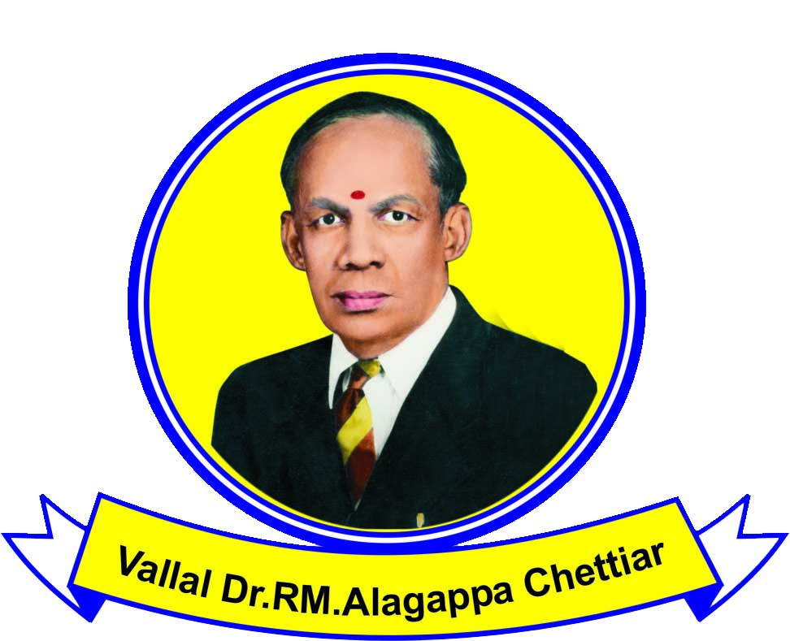
ALAGAPPA UNIVERSITY
(Re-Accredited with “A” grade by NAAC)
KARAIKUDI - 630003

APPLICATION FOR ADMISSION TO THE CONVOCATION
- The application with the required fee etc. should reach this office on or before …………………

- Candidates should read the instructions very carefully before filling the columns.
Name of the candidate and Address for communication with pin code

Mobile No.:

IN PERSON
IN ABSENTIA

Name of the Register Month & Year of Branch Class
Degree for which Number Passing Optional Subject obtained
Application is made
1 2 3 4 5

Tick in the appropriate box Sex: Male Female
1.Name of the candidate in English
(in CAPITAL LETTERS) _____________________________________________________
in Tamil
2.Father’s Name in English
_____________________________________________________
In Tamil
3.Mother’s Name in English
_____________________________________________________
In Tamil
4.College/Department/where studied:
5.If the candidate had already been Degree Date of Name of the College/
admitted to a convocation for any Convocation Dept. Studied
degree either in person or in _____________________________________________________
absentia, specify the details,

TO BE RETAINED BY THE COLLEGE OFFICE/UNIVERSITY DEPARTMENT
(Details to be filled up by the candidate)

Name of the Candidate
Degree for which Reg.No. Month & Year
application is made

College/Dept. through which qualified

6. Whether application was ever made previously for admission to
this degree and if so state the year, rejection of application if any :
and the reason therefor.
SL.No. | Details | Fees
1.  2.  3. | Convocation Fee  - In Person  (Medalwinners/Rank Holders in PG/M.Phil only)  - In Absentia  (Others)  Ph.D  Search fee per year  (Other than current batch) | Rs.600/-  Rs.750/-  Rs.750/-  Rs.200/-

7. PAYMENT DETAILS

Amount :

Date of Payment :

D.D.Number :

Name and Place of Bank :

8. The following certificates must be enclosed.

- Attested copy of previous Degree Certificate.(UG or PG Convocation)
- Attested copy of Provisional certificate for which the convocation is made.
- Attested copy of T.C for which convocation application is made.
- Demand Draft drawn in any bank in favour of “THE REGISTRAR, ALAGAPPA UNIVERSITY” payable at Karaikudi.
- Attested Xerox Copy of Cumulative Mark Statement of the degree for which application is made.
- For Ph.D - Attested copy of Ph.D Award Notification.

Station :
Signature of the Candidate
Date :
FORWARDED

Office Seal Signature of the Principal/
with Date Head of the Department

